Observing Amazon's ingenious digital OOH campaign to promote reading

In a note of brilliance, Amazon promoted the editor's choice of books and top charting books to avid readers through digital Outdoor advertising

It is rare to see reading be promoted on a billboard. Yet, Amazon the American multinational technological and commercial giant did it using a tactful approach with big returns in audience perception and traffic. This campaign made its way to the social media sphere, and made a mark there too without paid artificial push or other promotions.

### The Client: Amazon

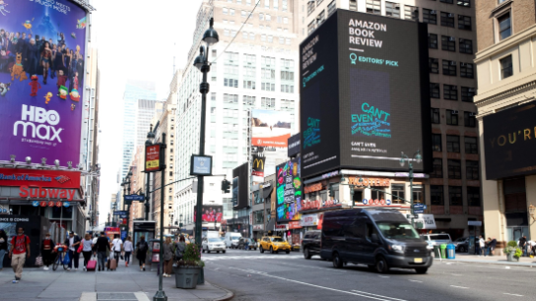

New york digital wallscape from Amazon featuring ‘Can't Even: How Millennials Became the Burnout Generation’ written by Anne Helen Petersen

Amazon has its own ebook reader, the highly popular and common kindle. In an effort to promote their electronic reading platform and also make people notice newly released highly acclaimed books they wanted a digital OOH campaign that promised to elevate audience reach through organic searches and awareness.

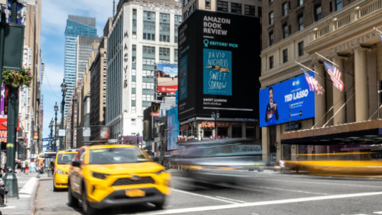

Amazon sharing the novel ‘Sweet Sorrow’ by David Nicholls on their digital wallscape

In order to improve recognition Amazon used digital bulletins for a period of 8 weeks. Specifically, it was done during the cycle of August 3rd and ended on September 27th. The main aim of the campaign was to excite the everyday avid readers and also the featured authors such that it pushes the habit of online reading and also improves the positive perception of the amazon books.

### The Campaign and tactics employed to improve impressions

Since this was a solo OOH advertising exercise the billboard placement was very important. Amazon chose the placement to be Penn Station, New York which recorded a high influx of working professionals and people from different walks of life. This placement ensured that they would touch their target demographic and possibly even make good impressions.

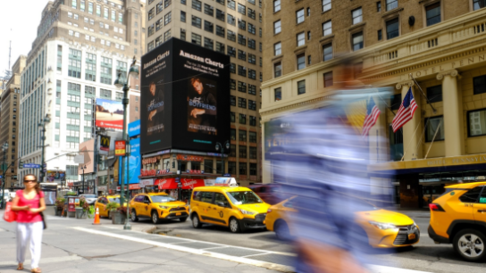

Amazon sharing ‘The Anti-Boyfriend’ a novel by Penelope Ward

It was also ensured that the displays would change every week with 3 books curated by the editors or that it was included in the top sellers. Since it was a digital display the creative face for each book was of paramount importance. All books creative book covers were meticulously placed for easy identification and links were shared for buyers aid.

### Organic awareness and social media impressions

Conversions and positive impressions are what we aim for through any great OOH campaign. With Amazon books, a significant IRL to URL convergence was observed. Nearly every single featured author shared their work on the digital channels and this made for significant organic search improvements. The platforms we observed for uptick were Twitter and Instagram.

Our estimates report that in Instagram alone organic searches rose to more than 12.4 million impressions through all shared channels and every author share reached their followers and so on.

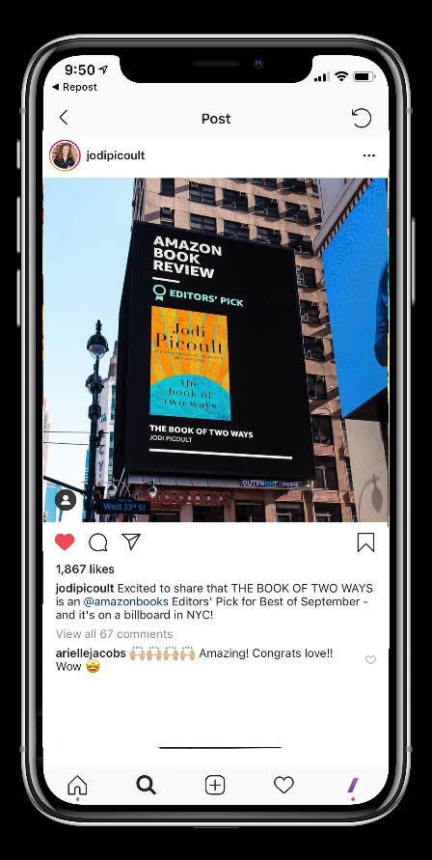

For example, this is shared by Jodi Picoult and the billboard featured her novel ’The Book of Two Ways’

In Twitter, the potential reach is estimated to be in massive retweets, shares and likes to be at around 1.96 million or more. And considering that estimates in twitter can only be roughly observed the representational figures could be much higher.

Both these estimates show us that using social media with an OOH campaign is the best possible way to observe organic searches and improve unaided awareness.

### Leveraging OOH impact through the study findings

The measurable success of any outdoor advertisement campaign is through the trail left behind. Within 8 weeks of digital outdoor advertising, the total reach passed over roughly 14 million people. And these are estimates available via only 2 major social media channels but if we probe further there will be a much larger impact. Based on this it is easy to state that digital Out-of-Home adverts are the way forward in capturing audiences and boosting traffic.

All data analysed and used in this case study is credited to Amazon and Outfront Media.

**Bibliography**

Outfront Media. (2020). *Amazon Books*. Amazon Books. https://www.outfrontmedia.com/-/media/files/case-studies/amazon-books-case-study.pdf